4D QA Phantom System Assembly Instructions
(Revised May 2009)

Parts List:

Layer 1

Programmable Controller (A)
Tie-rod Connector

Stepper Motor/Driver (B)
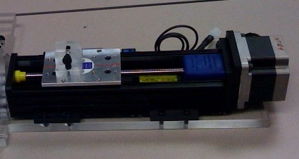

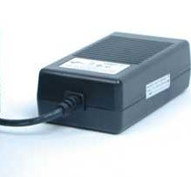
Layer 2

Power Module (C)
Tie-Rod (D)

Layer 3

Base Tray
(ramps)

Layer 4

Top Tray
(wheels)
4D QA Phantom System Assembly Instructions (cont.’d)

Assembly:

Stepper Motor and Trays

- Attach bottom tray (ramps up) to stepper motor/driver assembly (B) using nylon screws. Place top tray onto bottom tray, wheels down, making sure that wheels are aligned with center grooves of bottom tray. The top tray should move freely along the ramps of the bottom tray.
- Attach tie-rod (D) to stepper motor/driver assembly (B) at the tie-rod connector.
- Attach tie-rod (D) to top tray at the top tray tie-rod connector.

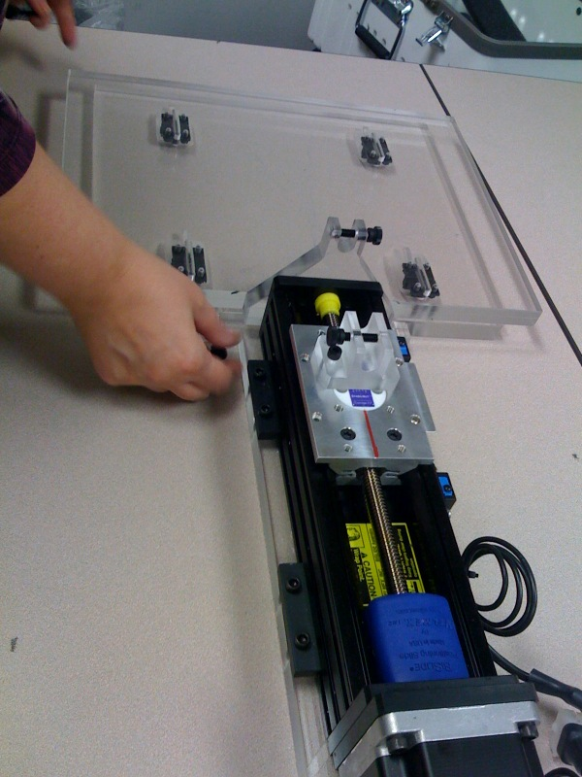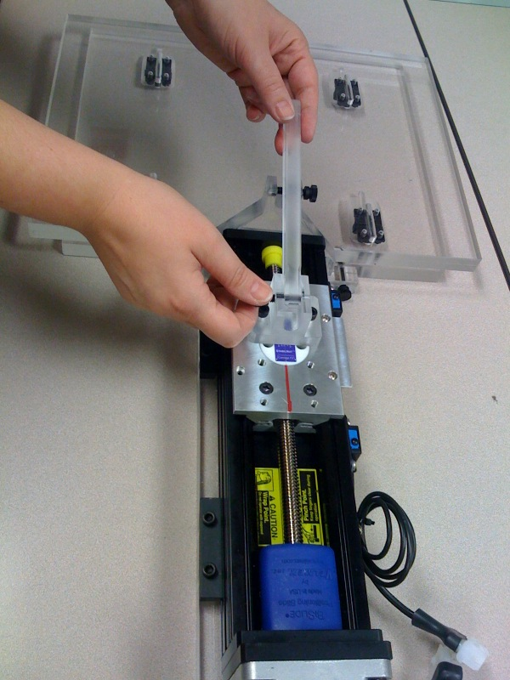

Programmable controller and power module

- Connect programmable controller (A) power and limiter cords to stepper motor/driver assembly (B) multi-pin connections (the two connectors are of distinct pin configurations).
- Connect power module (C) to programmable controller (A) (This connector is also a unique pin connector configuration).
- Connect power module (C) to room power using standard power cord.

Testing / Safety / Final Set-up

- Run the 4D QA system in “free-breathing” mode by pressing the green “run” button on the front face of the programmable controller (A).
- Observe the travel of the two trays and ensure that the motion of the trays appears smooth and is clear of and obstructions.
- Stop the phantom motion by pressing the red “stop” button on the front face of the programmable controller (A).
- Make certain that enough slack is also available in the power cords for all components to account for couch movement, etc.
- Before starting any set-up procedures, “jog” the top tray back to its starting position by pressing and holding the white “- jog“ button on the front face of the programmable controller (A) until the top tray stops at its home position (at bottom of the ramp).
- Proceed with placement of phantom onto top tray for irradiation set-up.
- Press green button to start motion.

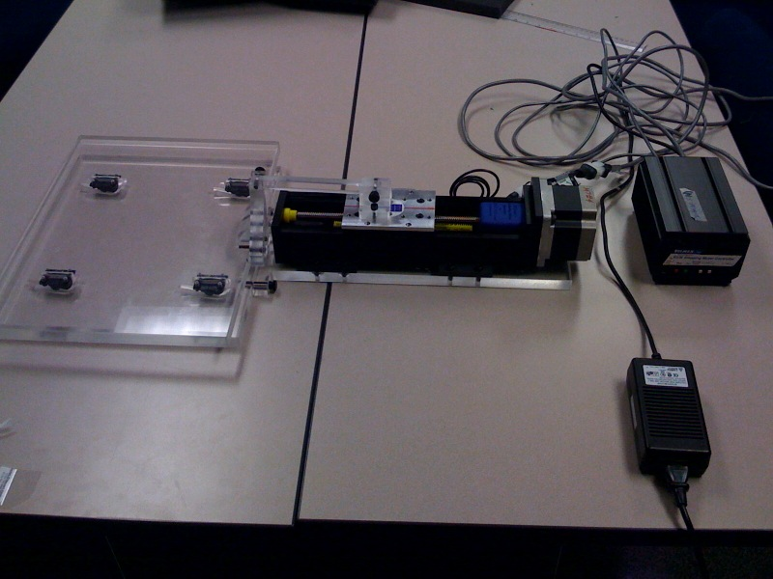
Align with sagittal laser

Final QA System Assembly

Align red line marked on Stepper Motor/Driver (B), with the sagittal laser.
(B)

